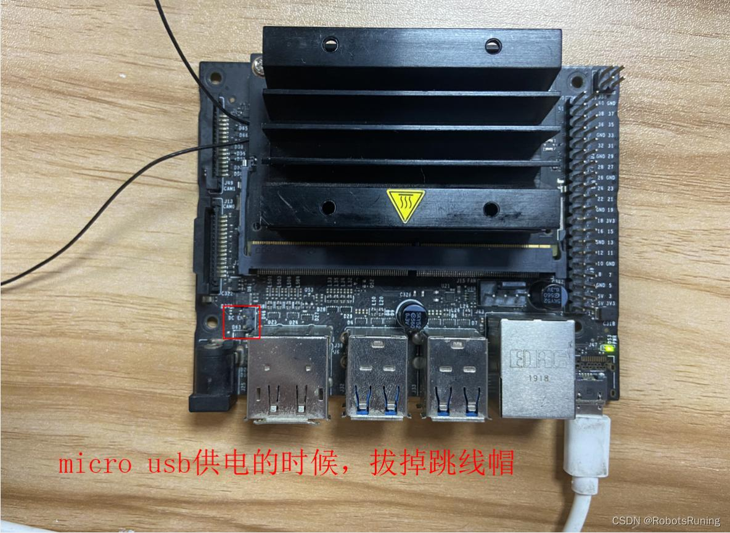


REPUBLIC OF CAMEROON
*********************************
PEACE-WORK-FATHERLAND
*********************************
UNIVERISTY OF BUEA
*********************************

NAME OF STUDENT : OBIH DAVID CHIMAOBI
MATRICULATION number : FE22A421
Student contact : 679225169
NAME OF INSTRUCTOR : Dr. KEMENI VALERY

Final Year project Activity Report
Design of a high Performance Computer
Point Addressing and setting upgrades of service jetson
Jetson Nano Nvidia module

Objectives:
The main objective of this report is to show case the progress of the project and also sight the difficulty and hindrances that push backward the progress of this project and also the aid of the lecturer to provide insight of the projects.
This document brings more light on the hardware, software and program/project development space which a jetson dev module. Nvidia provide a developer space known as jetpack which provide an ubuntu powered OS to project out the activity of the module and the objectives are to see on how to construct plus build out the best result form this module.
Jetson Nvidia has multiple possibility which converges to objective to build a four layer edge computing device that can carry out simultaneous operations and control at high speed , great accuracy and more enhancement.

Title: Full environment installation and control process of the various packages of the Jetpack provision OS.
What is a Jetson nano Module: this is powerful AI development kit that is able to carry out several operations and be built to undergo variety of computing activities. these various activities are;
- Edge computing
- Robotics
- Artificial Intelligence (AI)
- Computer vision
- Embedded systems
- Autonomous devices
- IoT applications
It is essentially a miniature Linux computer equipped with a GPU optimized for AI and parallel computing.
NB: Multiple retailers and variety of companies in partnership with the Nvidia provides the variant of the Jetson nano developer Kit, example: Okdo
Unlike a normal PC CPU-focused system, the Jetson Nano combines:
- ARM-based CPU
- CUDA-capable NVIDIA GPU
- AI acceleration
- GPIO hardware interfaces
This allows it to process camera feeds, sensors, neural networks, and real-time data directly on the device without relying heavily on cloud servers.
What the Jetson Nano Does
The Jetson Nano acts as an:
AI processing node, Embedded server, Vision processing unit, Robotics controller, Edge inference machine, Distributed computing device.
It runs Linux (Ubuntu-based Jetpack OS) and can execute:
- Python
- C/C++
- CUDA applications
- OpenCV
- PyTorch
- TensorFlow
- ROS (Robot Operating System)
- Docker containers

Main Hardware Components
CPU
Quad-core ARM Cortex-A57 processor.
Handles:
- Operating system
- General computing
- Networking
- Logic and control

GPU
128-core Maxwell GPU.
Handles:
- CUDA acceleration
- AI inference
- Parallel computing
- Image/video processing
This is the most important component for AI workloads.

RAM
Usually:
- 4GB LPDDR4 (classic Nano)
- Some 2GB versions exist
Used for:
- AI models
- OS memory
- Video processing
- Applications

Interfaces
The Jetson Nano includes:
USB ports, HDMI and DisplayPort, CSI camera connector, Ethernet, GPIO pins, I2C, SPI UART, and MicroSD storage.
This allows connection to:
- Cameras
- Sensors
- Motors
- Displays
- Storage devices
- Network switches
- Other Jetsons

What It Can Accomplish
1. AI and Deep Learning
The Nano can run:
- YOLO object detection
- Face recognition
- Image classification
- Speech recognition
- Tracking systems
Example:
- Security surveillance
- Smart cameras
- AI drones

2. Computer Vision
Using:
- OpenCV
- CUDA acceleration
- CSI cameras
It can:
- Detect objects
- Count people
- Track movement
- Analyse traffic
- Read license plates

3. Robotics
The Nano is heavily used in robotics because it can:
- Process sensors
- Control motors
- Run AI navigation
- Handle SLAM
- Communicate with microcontrollers
Examples:
- Autonomous robots
- Warehouse robots
- AI vehicles

4. Edge Computing
Instead of sending data to cloud servers, the Jetson processes data locally.
Advantages:
- Lower latency
- Faster response
- Reduced bandwidth usage
- Better privacy
This is critical for:
- Real-time AI
- Industrial automation
- Smart cities

Cluster / HPC Project Context
Since you are building a multi-node Jetson system, each Nano can become:
- A compute node
- A camera-processing node
- A storage node
- A network controller
- An inference node
You can interconnect them through:
- Ethernet switch
- MQTT
- SSH
- Docker Swarm
- Kubernetes
- MPI
This transforms several small Jetsons into a distributed edge-computing cluster.

What Is Required to Use a Jetson Nano
1. Power Supply
Very important.
Typical requirement:
- 5V / 4A barrel jack supply
Insufficient power causes:
- Random shutdowns
- Boot failures
- USB instability
- AI processing crashes
For ramp/power distribution design:
- Stable regulated 5V rail
- Adequate current capacity
- Cooling consideration
This design is to follow the path to design a cluster of multiple node for edge computing and data processing.

2. Storage
Usually:
- MicroSD card (minimum 32GB recommended)
Used for:
- Operating system
- AI models
- Software
High-end setups may use:
- SSD via USB

3. Operating System
You flash:
- NVIDIA JetPack SDK
JetPack includes:
- Ubuntu Linux
- CUDA
- cuDNN
- TensorRT
- OpenCV support
Official downloads:
- NVIDIA JetPack SDK
- NVIDIA Jetson Downloads Center

Additional Things Commonly Required
Cooling
The Nano gets hot under AI workloads.
Recommended:
- Heat sink
- Active fan
- Proper airflow
For cluster systems:
- Central airflow path
- Rack ventilation

Networking
For a cluster:
- Gigabit Ethernet switch
- Static IP configuration
- SSH enabled

Cameras
Common choices:
- CSI camera modules
- USB webcams
Used for:
- AI vision
- Video analytics
- Robotics

Software Stack
Most Jetson projects install:
- CUDA
- OpenCV
- PyTorch
- TensorFlow
- Docker
- MQTT
- ROS

Practical Real-World Applications
Smart Surveillance
AI cameras with:
- Intrusion detection
- Face recognition
- Tracking

AI Traffic Monitoring
- Vehicle counting
- Plate recognition
- Traffic flow analysis

Edge AI Server
A local AI inference server for:
- Factories
- Schools
- Hospitals
- Smart homes

Mini Supercomputer / HPC Cluster
Multiple Jetsons can:
- Share workloads
- Run distributed AI
- Simulate HPC concepts
- Execute parallel computing tasks
This details and processing ability aligns to the detail and foster a possible design of our AI cluster and possible the discovery of new ways to enhance the science relative to AI.
Limitations of the Jetson Nano
Despite being powerful for embedded AI, it has limits:
- Limited RAM
- Lower CPU performance than desktops
- No high-end GPU like RTX cards
- Limited PCIe expansion
- Thermal constraints
Heavy AI training is difficult.
The Nano is best for:
- AI inference
- Edge computing
- Lightweight distributed computing
Not:
- Massive LLM training
- Large-scale HPC simulation

Why the Jetson Nano Is Important
The Nano bridges:
- Embedded systems
- AI acceleration
- Robotics
- Edge computing
- Distributed systems
It allows you to build:
- Real AI infrastructure
- Low-power clusters
- Intelligent devices
- Research prototypes
- Industrial edge systems
This information above were to sign in the presence of the jetson Nano as an innovative and highly productive device use both in laboratory and also in industrial activities.
Despite the high cost of each Module it provides enhance and more productive aspect in the study of embedded AI and other forms of electronic related projects.

Jetson nano environment build
Jetpack OS provided packages
this is quit fast operation in the recent models of the NVidia dev’s Kit since they are built with the recent modelling chips, memory and also power processing components further the recent LLM (large language Model) processing science as deep learning and supervised learning. the other variant as the Jetson Nano Orin dev’ kit is on other level compared to the jetson nano module since it can be processes with a power supply ~9V/5.1A (45W) power supply and only that is a great difference and let not just speak of its statistic which are way high to that of the Jetson nano module.
Installation of Jetpack OS
To install the operating system on an NVIDIA Jetson module such as the NVIDIA Jetson Nano Developer Kit, you install JetPack SDK, which contains:
- Ubuntu-based Linux OS (Jetson Linux / L4T)
- CUDA
- cuDNN
- TensorRT
- OpenCV support
- AI acceleration libraries
- Drivers and firmware
The installation method depends on your Jetson model. Since your project discussions indicate you are using a standard Jetson Nano module, the easiest method is:
Method 1 — Flash JetPack to microSD Card (Recommended for Jetson Nano Dev Kit)
Requirements
Hardware
- Jetson Nano Developer Kit
- microSD card (minimum 32GB, Class 10/UHS-1 recommended)
- 5V/4A power supply (barrel jack recommended)
- HDMI monitor
- USB keyboard and mouse
- Ethernet cable or Wi-Fi dongle
PC Requirements
A Windows, Linux, or Mac computer for preparing the SD card.

Step 1 — Download JetPack Image
Go to the official NVIDIA Jetson download page:
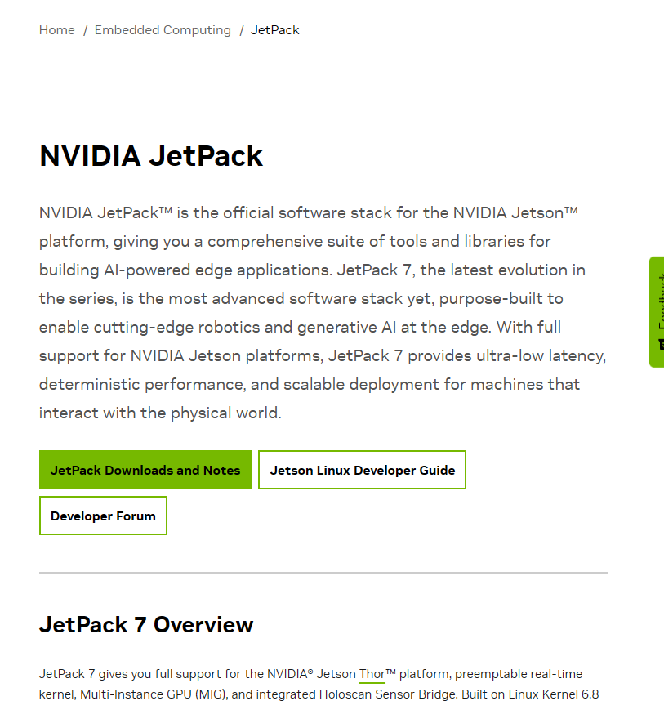
NVIDIA JetPack Downloads

For Jetson Nano, download:
- Jetson Nano Developer Kit SD Card Image
You may also access Jetson software from:
NVIDIA Jetson Developer Center
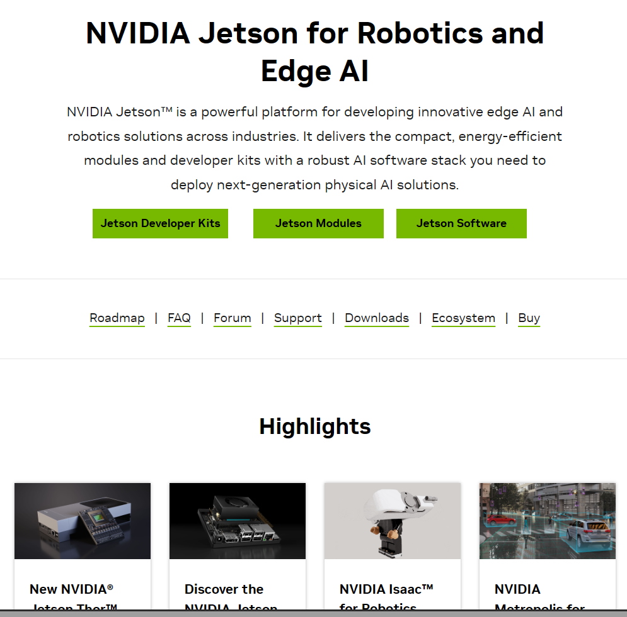

Step 2 — Download Balena Etcher
Balena Etcher is used to flash the image to the SD card.
Download:
Balena Etcher
Install it on your PC.
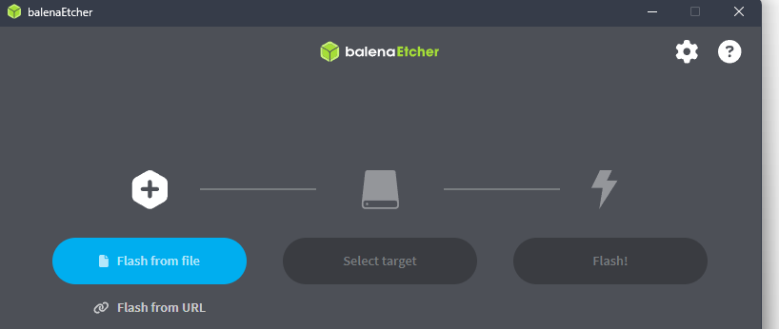
Step 3 — Insert microSD Card into PC
Use:
- SD card slot
or
- USB SD card reader

Step 4 — Flash the Image
Open Balena Etcher.
Process:
- Select downloaded JetPack image (.img or .zip)
- Select microSD card
- Click Flash
Wait until flashing completes.
This may take 5–20 minutes depending on the SD card speed.
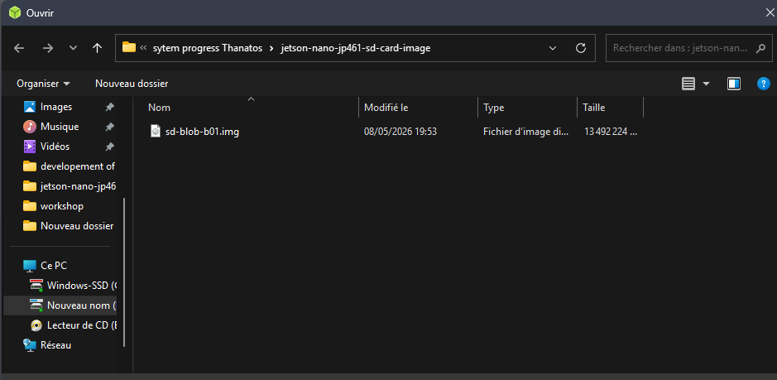

Step 5 — Insert SD Card into Jetson Nano
Insert the flashed microSD card into the slot under the board.

Step 6 — Connect Peripherals
Connect:
- HDMI display
- Keyboard
- Mouse
- Ethernet cable (recommended initially)

Step 7 — Connect Power
For stability in cluster or AI workloads, use:
- 5V/4A barrel jack supply
Avoid weak USB phone chargers.
If using barrel jack:
- Place jumper on J48 power pins (important)

Step 8 — First Boot
Power ON the Jetson Nano.
You should see:
- NVIDIA logo
- Ubuntu setup wizard
Setup includes:
- Username
- Password
- Time zone
- Keyboard layout
- Network

Step 9 — Update the System
Open Terminal and run:
Sudo apt update
sudo apt upgrade -y
Then reboot:
sudo reboot

Step 10 — Verify JetPack Installation
Check system info:
cat /etc/nv_tegra_release
Check CUDA:
nvcc --version
Check Python:
python3 --version

Jetson Nano Headless Setup & OpenCV CUDA Installation Report
This operation is long and require a proper search and process control of command lines on the ubuntu Terminal and verify the directory positioning and environment files that are required to position
- CUDA
- OPEN CV
- Build directory ( -desktop:~/opencv_build/opencv/build)
Summary of operation
Successfully configured an NVIDIA Jetson Nano Developer Kit for headless operation and installed OpenCV 4.5.0 with full CUDA acceleration. The system is now fully accessible via SSH and WiFi, with GPU-accelerated computer vision capabilities verified.

Component | Specification
Hardware | NVIDIA Jetson Nano Developer Kit
OS | Ubuntu 18.04.6 LTS (L4T 32.7.6)
Kernel | 4.9.337-tegra aarch64
CUDA Version | 10.2
cuDNN Version | 8.2.1
Python Version | 3.6.9
OpenCV Version | 4.5.0 (CUDA enabled)

Headless Configuration
Task | Status | Details
WiFi Adapter Setup | Complete | LB-Link MT7601U (148f:7601)
WiFi Connection | Complete | Connected to PADDYearpay1
IP Address | Obtained | 192.168.1.25
SSH Server | Running | Port 22 accessible
Remote Desktop (xrdp) | Configured | Xfce/LXDE desktop
Swap Space | Expanded | 6GB + existing = 7.9GB total

Network Configuration:
Interface: wlan0
IPv4: 192.168.1.25/24
Gateway: 192.168.1.1
Status: Connected
They are various way to undergo headless mode on a jetson module the one mostly common ( GUI mode) using Xrdp or VNC but those methods are going to be expanded later in other documentation.
System Updates & Fixes
Issue | Resolution
NVIDIA bootloader configuration error | Resolved with post-install script modifications
xrdp session crash | Switched from GNOME to Xfce/LXDE desktop
apt lock conflicts | Cleared lock files and killed stuck processes
OpenCV compilation CUDA error (cuda/std/tuple) | Downgraded from 4.10.0 to 4.5.0

OpenCV 4.5.0 with CUDA Installation
Command lines
# 5. Download OpenCV 4.5.0 (Crucial for Jetson Nano)
mkdir -p ~/opencv_build && cd ~/opencv_build
wget -O opencv.zip https://github.com/opencv/opencv/archive/4.5.0.zip
wget -O opencv_contrib.zip https://github.com/opencv/opencv_contrib/archive/4.5.0.zip
unzip opencv.zip && unzip opencv_contrib.zip
mv opencv-4.5.0 opencv && mv opencv_contrib-4.5.0 opencv_contrib
rm opencv.zip opencv_contrib.zip

# 6. CMake Configuration (CUDA Architecture 5.3 is critical for Nano)
cd ~/opencv_build/opencv
mkdir -p build && cd build

cmake -D CMAKE_BUILD_TYPE=RELEASE \
-D CMAKE_INSTALL_PREFIX=/usr/local \
-D WITH_CUDA=ON \
-D WITH_CUDNN=ON \
-D CUDA_ARCH_BIN=5.3 \
-D CUDA_ARCH_PTX="" \
-D ENABLE_FAST_MATH=ON \
-D CUDA_FAST_MATH=ON \
-D WITH_CUBLAS=ON \
-D BUILD_opencv_python3=ON \
-D BUILD_opencv_python2=OFF \
-D OPENCV_EXTRA_MODULES_PATH=~/opencv_build/opencv_contrib/modules \
-D PYTHON3_EXECUTABLE=$(which python3) \
-D PYTHON3_NUMPY_INCLUDE_DIRS=$(python3 -c "import numpy; print(numpy.get_include())") \
-D BUILD_EXAMPLES=OFF \
-D BUILD_TESTS=OFF ..

# 7. Compile and Install (Takes 2-4 hours)
make -j4
sudo make install
sudo ldconfig

# 8. Fix potential NVIDIA linker issue
sudo sh -c "echo '/usr/local/cuda/lib64' >> /etc/ld.so.conf.d/nvidia-tegra.conf"
sudo ldconfig
Verification & Cleanup
# 9. Verify Installation
python3 -c "import cv2; print('OpenCV:', cv2.__version__)"
python3 -c "import cv2; print('CUDA Devices:', cv2.cuda.getCudaEnabledDeviceCount())"
python3 -c "print(cv2.getBuildInformation())" | grep "CUDA"

# 10. Remove Build Directory to save space (Optional)
rm -rf ~/opencv_build

# 11. Disable Swap (Optional, to save SD card wear)
sudo swapoff /swapfile
sudo rm /swapfile
Final Summary of Achievements
At this level
- Headless Operation: The Jetson Nano is fully operational without a monitor, controlled via SSH (192.168.1.25) and Remote Desktop (xrdp).
- WiFi Connectivity: Successfully configured the LB-Link MT7601U adapter (ID 148f:7601).
- OpenCV 4.5.0 with CUDA: Successfully compiled and installed OpenCV 4.5.0 from source. This specific version is the most stable release compatible with the Jetson Nano's final JetPack version .
- GPU Acceleration: Verified that OpenCV can access the Jetson Nano's CUDA cores, enabling hardware acceleration for computer vision tasks.
- Environmental Stability: The system is locked into the final supported configuration by NVIDIA (JetPack 4.6 / CUDA 10.2), which is a mature and highly stable environment

